Abstract submission guidelines
For PhD students

Complete the following information, using the template hereafter:
- Title of the abstract
- Author’s names and email of contact
- Affiliation

Abstracts must be written in English.

The abstract should state the most important specific objectives, the major results (or expected results if none are applicable at this stage), and the most significant conclusions of the work.

Prepare your abstract relating to the topics covered during the summer school:
- Laser source development
- Laser industry 4.0
- Laser processing
- Quantum technologies
- Attosecond science

Please provide complete and accurate bibliographic information for all cited sources in the reference list. Include illustrations and captions.

The submission of abstracts for PhD students will open on February 5th, 2024.

Submission process calendar

- Submit your one-page abstract before March 8th, 2024.

- Participation to the Photonics TALENT Summer School is subject to review by the scientific committee from March 8th until April 5th, 2024.

A selection of posters will be considered for the poster session (with poster award). If your abstract is selected, you will receive a notification by email to send in your poster. You will receive an email informing you of the the committee’s decision between April 8th and April 12th.

After receiving acceptance notification, you will need to confirm acceptance by registering and paying on the SciencesConf platform between April 15th and May 17th. Registration will close on May 17th.

- Organize your visit to the summer school. We look forward to seeing you in Bordeaux on July 8th.

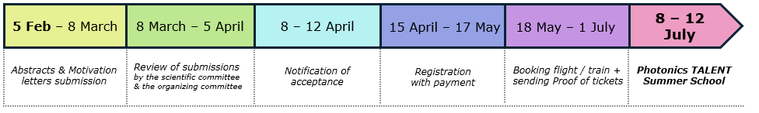

Title of the Abstract

Author’s name:
Author’s email:
Affiliation:

Abstract

One page abstract with figures.

Motivation letter submission guidelines
For master’s students

Complete the following information, using the template hereafter:
- Name
- Affiliation of your university
- What diploma are you preparing this year?
- Email of contact

Motivation letter must be written in English.

Motivate your participation to the Photonics TALENT International Summer School :
- Tell us why you'd like to take part in the Summer University?
- Explain what is your career plan?
- Explain what you expect from this event?
- Write about 20 lines

The submission of motivation letters for master’s students will open on February 5th, 2024.

Submission process calendar

- Submit your motivation letter before March 8th, 2024.

- Participation to the Photonics TALENT Summer School is subject to review by the scientific committee from March 8th until April 5th, 2024.

A limited number of letters will be selected and these students shall receive a scholarship to take part in the Summer School. If your letter is selected, you will be notified with the acceptance email between April 8th and April 12th.

- After receiving acceptance notification, you will need to confirm acceptance by registering and paying on the SciencesConf platform between April 15th and May 17th.
For students with grants, you must send us proof of your tickets to be reimbursed.
Registration will close on May 17th.

- Organize your visit to the summer school. We look forward to seeing you in Bordeaux on July 8th.

Motivation Letter

Name:
Affiliation of your university:
What diploma are you preparing this year:
Email of contact:

Motivate your participation to the Photonics TALENT International Summer School writting about 20 lines.

